**Business rules requirements**:

The bank is organized into branches. Each branch is in a particular city with an address and is identified by a unique branch-ID and a name. The bank monitors the assets of each branch. Each branch of the bank has a manager and an assistant manager who are employees of the bank.

Bank customers are identified by their social security numbers. The bank stores each customer’s name and address (apartment number, street number, state, city, and zip code). Customers may have several accounts and can take out loans that are managed as accounts as well. A customer may be associated with a particular branch and has a personal banker who works with the customer on their loan and bank transactions.

Bank employees are also identified by their social security numbers. The bank stores the name and telephone numbers of each employee and the names of the employee’s dependents. The bank also keeps track of the employee’s start date and, thus, length of employment. An employee at the bank works for one of the branches and reports to the manager of that branch. May have a manager and the manager is in charge of a certain number of employees.

The bank offers several types of accounts; savings, checking, money market, and loan accounts. An account can be held by more than one customer, and a customer can have more than one account. Each account is assigned a unique account number. The bank maintains a record of each account balance and the most recent date on which the account was accessed by each customer holding the account. In addition, saving and loan accounts have fixed interest rates, money market accounts have variable interest rates regularly updated based on the stock market. And overdrafts are recorded for each checking account.

A loan originates at a particular branch and can be held by one or more customers. A loan is identified by a unique loan number (similar to an account number). For each loan, the bank keeps track of the loan amount and the loan monthly re-payment amount.

The bank keeps track of all the transactions. A transaction is identified by a unique code and has a type of name. For example, “WD” is the code for withdrawal, and “CD” is for customer deposit. When a customer makes a transaction, the transaction record should identify the transaction code, the date, the hour, the amount, and the account. Some transactions are free but the bank charges for most of them. If a customer makes a chargeable transaction, the charge is also registered as a charge less transaction.

**REPORT:**

The business requirements for my bank project are, customers, employees, branches, accounts, transaction details. To run the business, bank needs employees who are going to manage the customers, and satisfy their needs like deposit, withdrawal of money and the bank provides loan for the customers. To get the benefits provided by the bank, the customers have to open a bank account which was done with the help of the employees of the bank. So, to find out the details of the branch like location, city and the manager name we need to store the branch details in the form of tables in database, So in future we need any details regarding the branch we can retrieve the data from the logical database and it is easy to access, Same for the employees, customers, accounts, transaction details. To store the data I have used MyPHPAdmin database. To develop webpages I have used HTML, CSS and to connect the web pages and database I have used php.

In application program design I have designed a login page, so only the admin can access the database. And each box in login.php represents the details of the bank like employees, branch etc. And the number in each box indicates that there are these many number of tuples in each table.

**Web page implementation :**

I have created 4 web pages:

1) Index.php (consists of login page)

2) Validate.php (It validates the user name and passcode this page is connected to database and checks login details are matching to the login details entered in database)

3) Login.php(This page consists of the bank portal| admin design )

4) Login validate.php(This page is connected to the database in this page the data from the database is displayed)

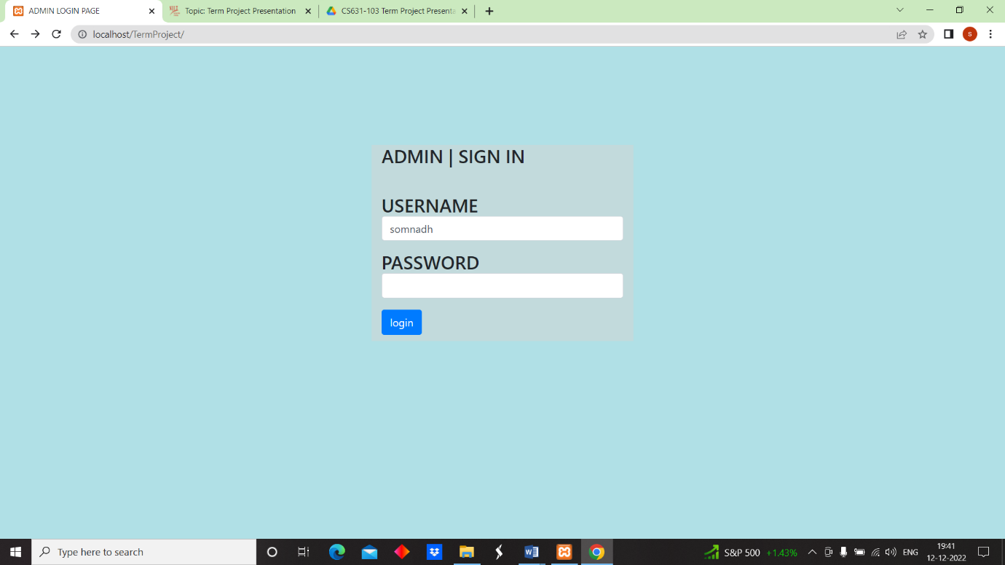

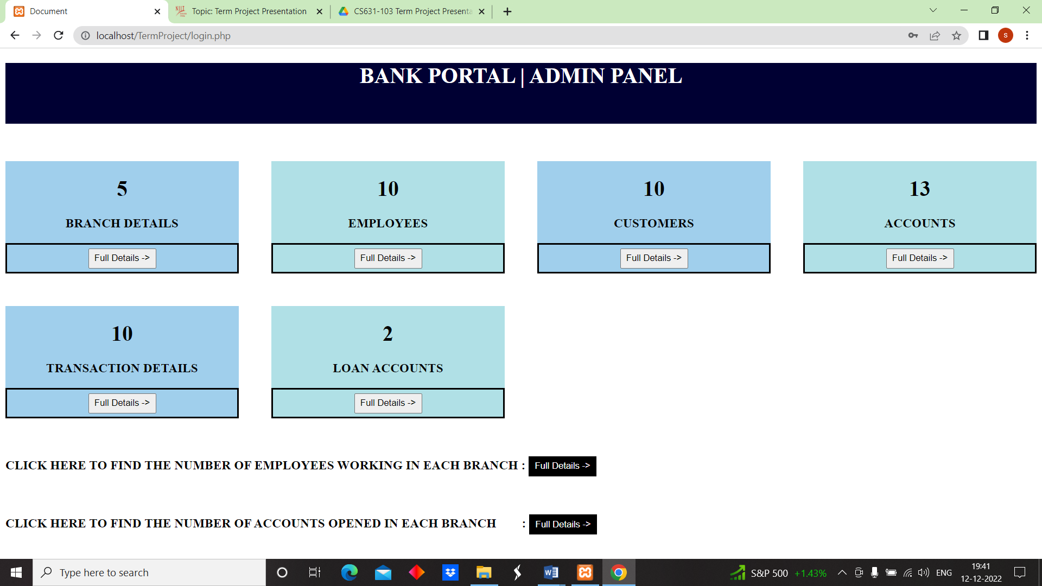

By clicking “Full Details” button on each box on the web page the following related web pages are going to get displayed.

**Branch Details Web Page**

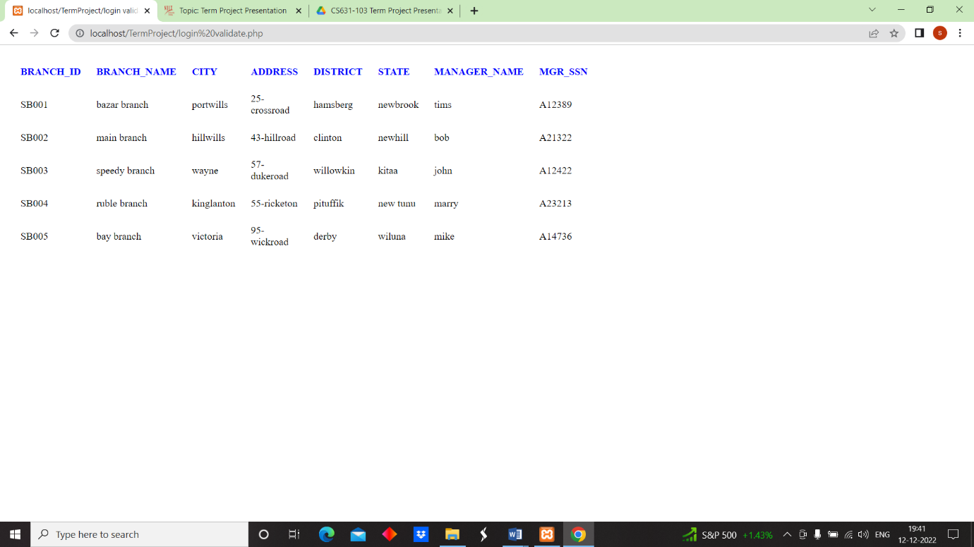

**Employees Details Web Page**

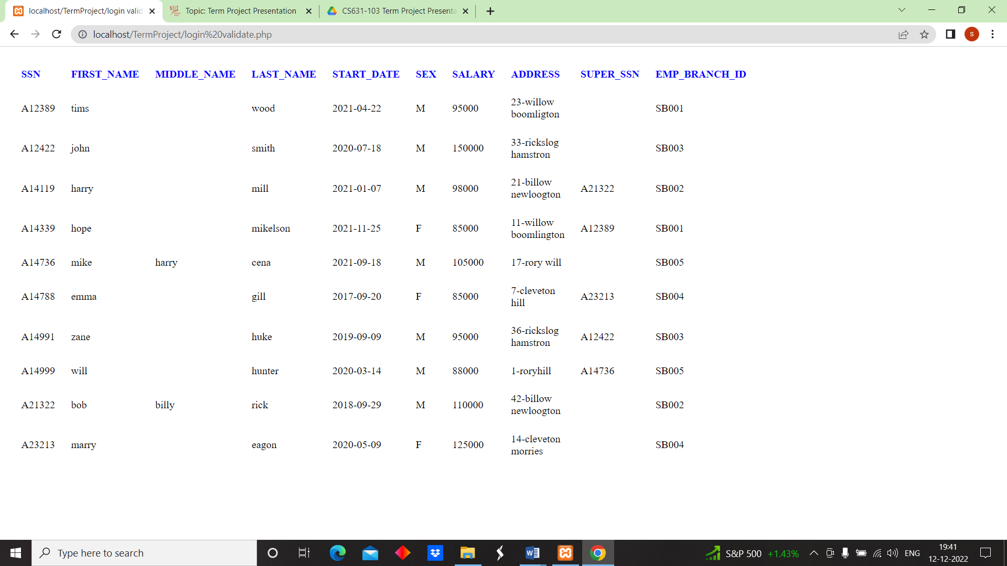

**Customer Details web page**

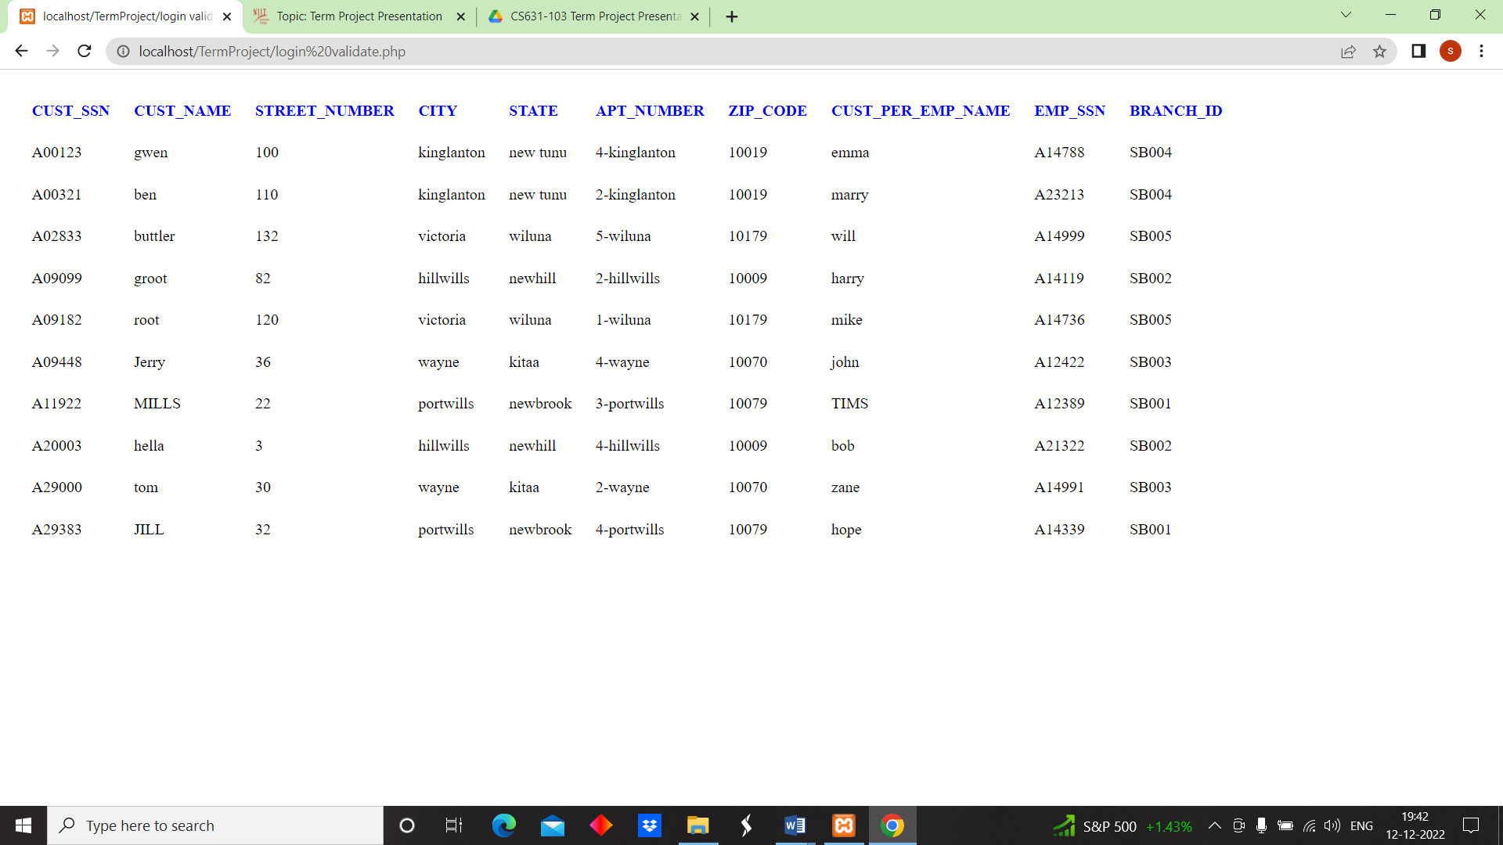

**Account Details Web Page**

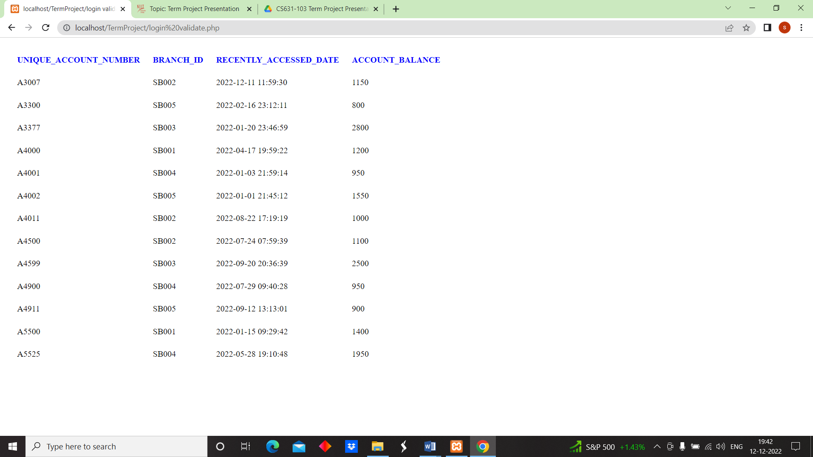

**Transactions Web Page**

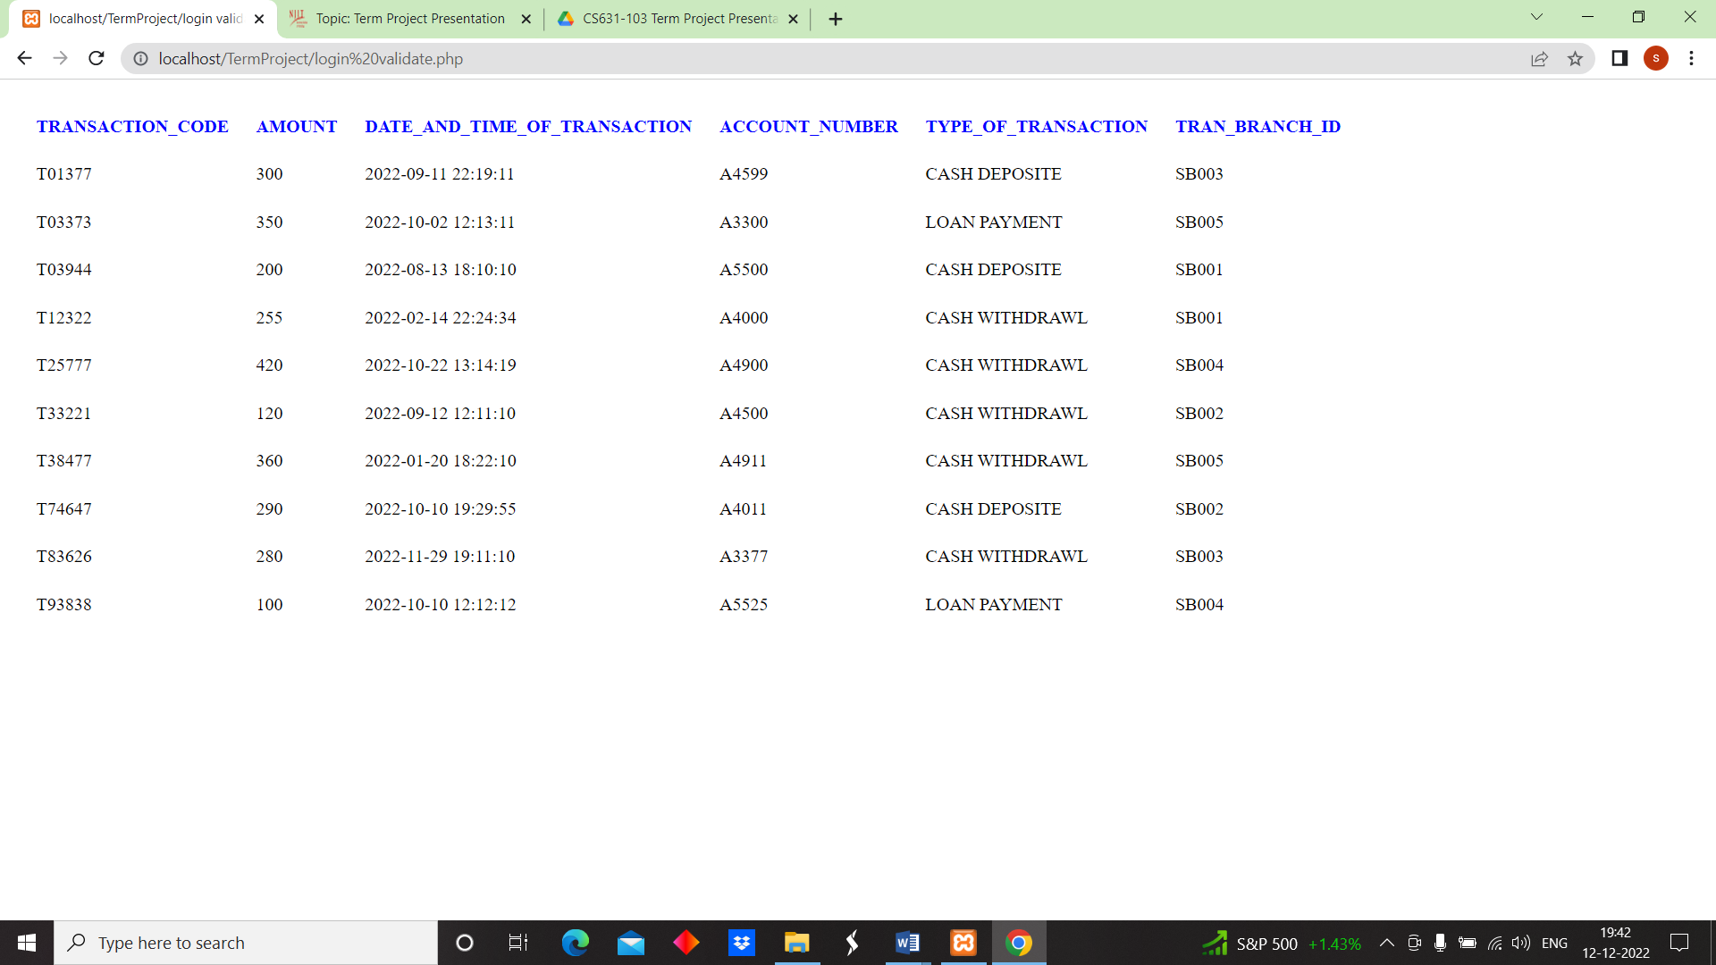

**Loan Account Web Page**

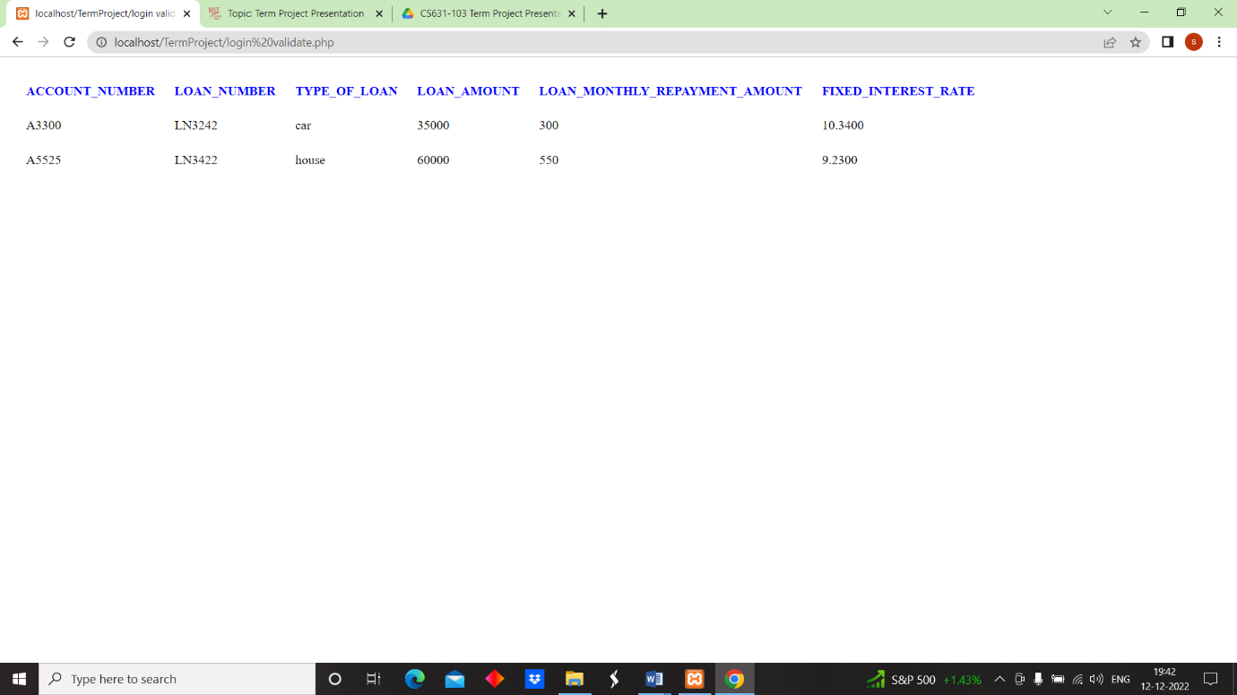

**Number of Employees working in each branch Details web Page**

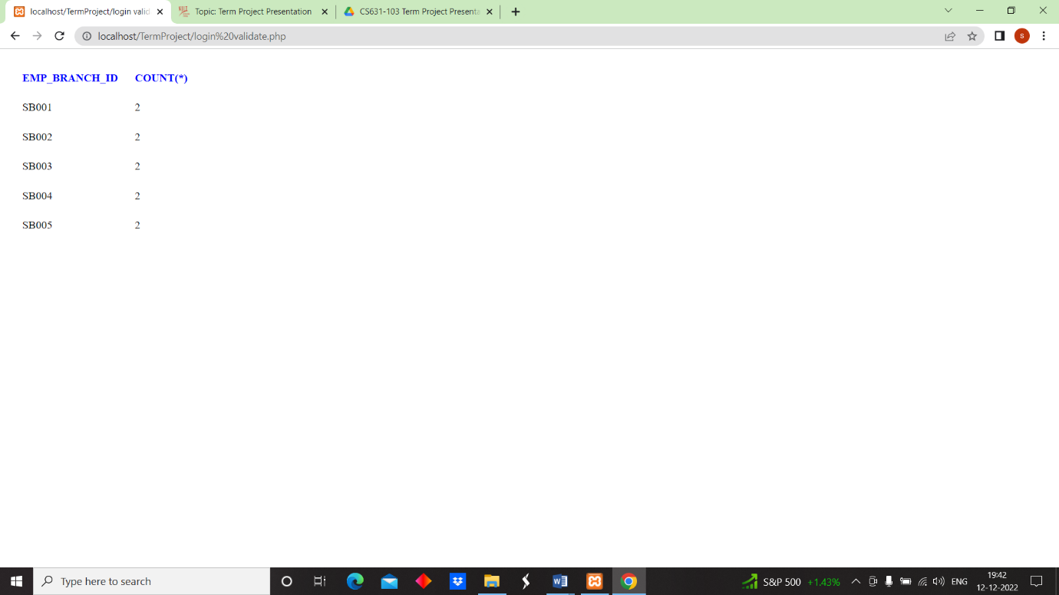

**Number of Accounts opened in Each Branch Web Page Details**

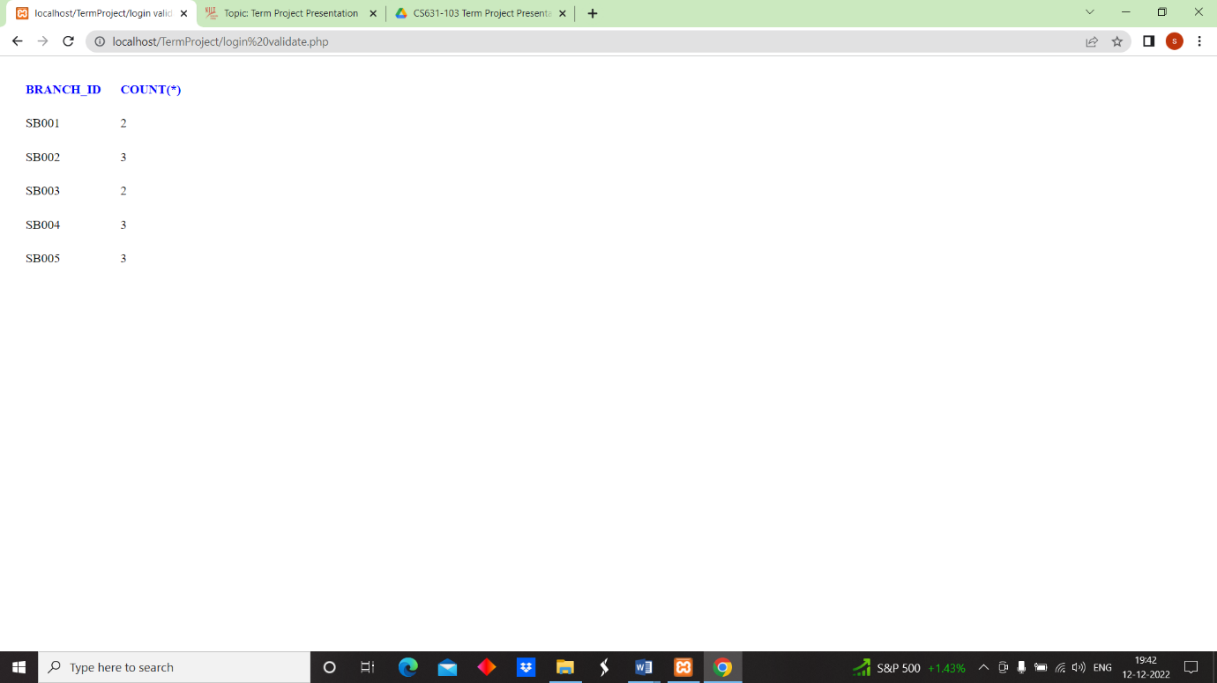

**Converting BRANCH table into 3NF:**



Primary key= branch_id.

Foreign key= MGR_SSN.

Super key= [Branch _id, branch_name], [branch_id].

Candidate key= branch_id.

**Inserting values into branch table**

insert into sk3395_fall2022.BRANCH(BRANCH_ID ,BRANCH_NAME ,CITY ,ADDRESS ,DISTRICT ,STATE ,MANAGER_NAME ) values('SB001','bazar branch','portwills','25-crossroad','hamsberg','newbrook','tims');

insert into sk3395_fall2022.BRANCH(BRANCH_ID ,BRANCH_NAME ,CITY ,ADDRESS ,DISTRICT ,STATE ,MANAGER_NAME ) values('SB002','main branch','hillwills','43-hillroad','clinton','newhill','bob');

insert into sk3395_fall2022.BRANCH(BRANCH_ID ,BRANCH_NAME ,CITY ,ADDRESS ,DISTRICT ,STATE ,MANAGER_NAME ) values('SB003','speedy branch','wayne','57-dukeroad','willowkin','kitaa','john');

insert into sk3395_fall2022.BRANCH(BRANCH_ID ,BRANCH_NAME ,CITY ,ADDRESS ,DISTRICT ,STATE ,MANAGER_NAME ) values('SB004','ruble branch','kinglanton','55-ricketon','pituffik','new tunu','marry');

insert into sk3395_fall2022.BRANCH(BRANCH_ID ,BRANCH_NAME ,CITY ,ADDRESS ,DISTRICT ,STATE ,MANAGER_NAME ) values('SB005','bay branch','victoria','95-wickroad','derby','wiluna','mike');

**FUNCTIONAL DEPENDENCIES**

branch_id, MGR_SSN -> Manager name

Branch_id, branch name -> city, district, address, state

Branch_id -> MGR_SSN, Manager name, branch name

**This relation is in 3NF.**

**Converting EMPLOYEE table into 3NF:**

Primary keys= SSN.

Foreign keys= emp_branch_id, SUPERSSN.

Super keys =[SSN, Start Date], [SSN]

Candidate key= SSN

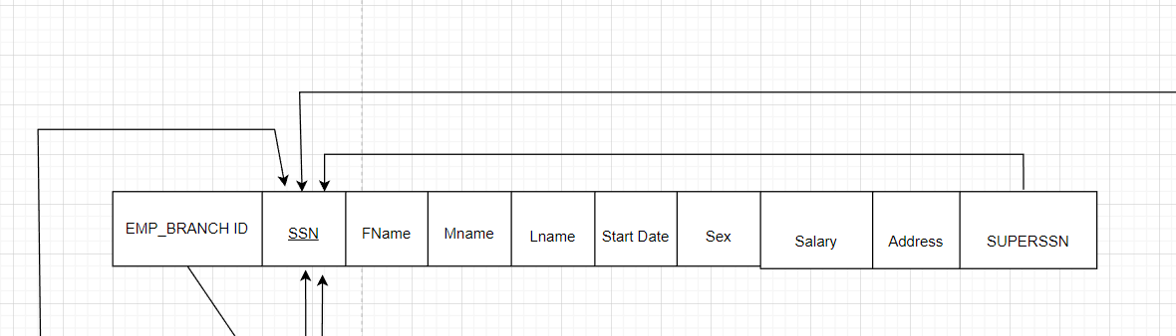

**FUNCTIONAL DEPENDENCIES**

SSN -> fname, Mname, Lname, Start date, salary, address

SSN, Start Date -> emp_branch_id, sex

SSN, Emp_branch_id -> superssn

**INSERTING VALUES INTO EMPLOYEE TABLE**

insert into sk3395_fall2022.employee values('A12389','tims',null,'wood','2021-04-22','M',95000,'23-willow boomligton',null,'SB001');

insert into sk3395_fall2022.employee values('A21322','bob','billy','rick','2018-09-29','M',110000,'42-billow newloogton',null,'SB002');

insert into sk3395_fall2022.employee values('A12422','john',null,'smith','2020-07-18','M',150000,'33-rickslog hamstron',null,'SB003');

insert into sk3395_fall2022.employee values('A23213','marry',null,'eagon','2020-05-09','F',125000,'14-cleveton morries',null,'SB004');

insert into sk3395_fall2022.employee values('A14736','mike','harry','cena','2021-09-18','M',105000,'17-rory will',null,'SB005');

insert into sk3395_fall2022.employee values('A14999','will',null,'hunter','2020-03-14','M',88000,'1-roryhill','A14736','SB005');

insert into sk3395_fall2022.employee values('A14788','emma',null,'gill','2017-09-20','F',85000,'7-cleveton hill','A23213','SB004');

insert into sk3395_fall2022.employee values('A14991','zane',null,'huke','2019-09-09','M',95000,'36-rickslog hamstron','A12422','SB003');

insert into sk3395_fall2022.employee values('A14119','harry',null,'mill','2021-01-07','M',98000,'21-billow newloogton','A21322','SB002');

insert into sk3395_fall2022.employee values('A14339','hope',null,'mikelson','2021-11-25','F',85000,'11-willow boomlington','A12389','SB001');

**This relation is in 3NF.**

**Converting TRANSACTION table into 3NF:**

Primary key= transaction_code.

Foreign key= tran_branch_id.

Super key= [Transaction_code, account_number], [Transaction_code]

Candidate key= transaction code.

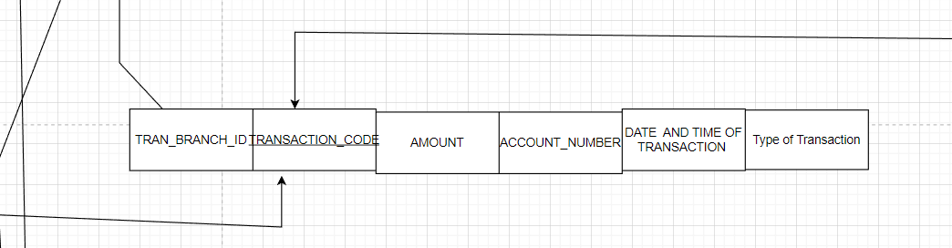

**FUNCTIONAL DEPENDENCIES**

Transaction_code -> amount, tran_branch_id.

Transaction_code, amount -> date and time of transaction, type of transaction

tran_branch_id -> Account_number

**Inserting values into transaction table**

insert into sk3395_fall2022.transactions values('T12322',255,'2022-02-14 22:24:34','A4000','CASH WITHDRAWL','SB001');

insert into sk3395_fall2022.transactions values('T33221',120,'2022-09-12 12:11:10','A4500','CASH WITHDRAWL','SB002');

insert into sk3395_fall2022.transactions values('T03944',200,'2022-08-13 18:10:10','A5500','CASH DEPOSITE','SB001');

insert into sk3395_fall2022.transactions values('T01377',300,'2022-09-11 22:19:11','A4599','CASH DEPOSITE','SB003');

insert into sk3395_fall2022.transactions values('T93838',100,'2022-10-10 12:12:12','A5525','LOAN PAYMENT','SB004');

insert into sk3395_fall2022.transactions values('T03373',350,'2022-10-02 12:13:11','A3300','LOAN PAYMENT','SB005');

insert into sk3395_fall2022.transactions values('T83626',280,'2022-11-29 19:11:10','A3377','CASH WITHDRAWL','SB003');

insert into sk3395_fall2022.transactions values('T25777',420,'2022-10-22 13:14:19','A4900','CASH WITHDRAWL','SB004');

insert into sk3395_fall2022.transactions values('T38477',360,'2022-01-20 18:22:10','A4911','CASH WITHDRAWL','SB005');

insert into sk3395_fall2022.transactions values('T74647',290,'2022-10-10 19:29:55','A4011','CASH DEPOSITE','SB002');

**This relation is in 3NF.**

**Converting ACCOUNTS table into 3NF:**

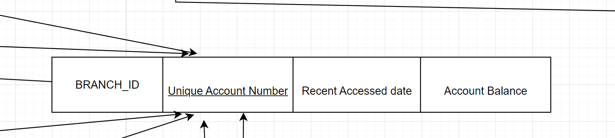

Primary key= unique­_account_number.

Super key= branch_id.

Super key= [Unique_account_number, branch id] ,[ branch id].

Candidate key= unique_account_number.

**FUNCTIONAL DEPENDENCIES**

Unique_account_number, branch id -> account balance.

Unique_ account_number -> recent accessed date, branch id

**Inserting values into ACCOUNTS table**

insert into sk3395_fall2022.accounts values('A3300','SB005','2022-02-16 23:12:11',800);

insert into sk3395_fall2022.accounts values('A4011','SB002','2022-08-22 17:19:19',1000);

insert into sk3395_fall2022.accounts values('A4000','SB001','2022-04-17 19:59:22',1200);

insert into sk3395_fall2022.accounts values('A4599','SB003','2022-09-20 20:36:39',2500);

insert into sk3395_fall2022.accounts values('A4900','SB004','2022-07-29 09:40:28',950);

insert into sk3395_fall2022.accounts values('A4911','SB005','2022-09-12 13:13:01',900);

insert into sk3395_fall2022.accounts values('A4500','SB002','2022-07-24 07:59:39',1100);

insert into sk3395_fall2022.accounts values('A5500','SB001','2022-01-15 09:29:42',1400);

insert into sk3395_fall2022.accounts values('A3377','SB003','2022-01-20 23:46:59',2800);

insert into sk3395_fall2022.accounts values('A5525','SB004','2022-05-28 19:10:48',1950);

insert into sk3395_fall2022.accounts values('A4002','SB005','2022-01-1 21:45:12',1550);

insert into sk3395_fall2022.accounts values('A4001','SB004','2022-01-3 21:59:14',950);

insert into sk3395_fall2022.accounts values('A3007','SB002','2022-12-11 11:59:30',1150);

**This table is in 3NF.**

**Converting LOAN ACCOUNT table into 3NF:**

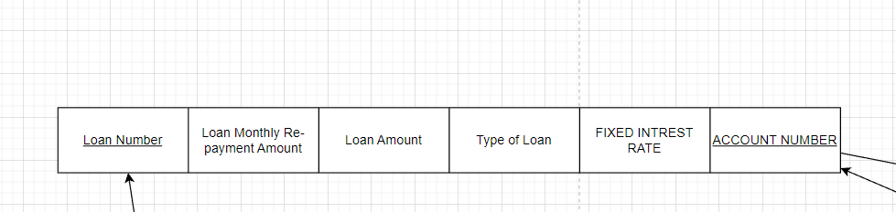

Primary key= loan number

Foreign key= account number

Super key= [Loan number, account number], [Loan number]

Candidate key= loan number

**Functional dependencies**

loan number -> loan amount, type of loan, account number.

Loan number, account number -> loan monthly re-payment amount, fixed interest rate.

**Inserting values into loan account**

insert into sk3395_fall2022.loan_account values('A5525','LN3422','house',60000,550,9.23);

insert into sk3395_fall2022.loan_account values('A3300','LN3242','car',35000,300,10.34);

**This relation is in 3NF.**

**Converting customers table into 3NF:**

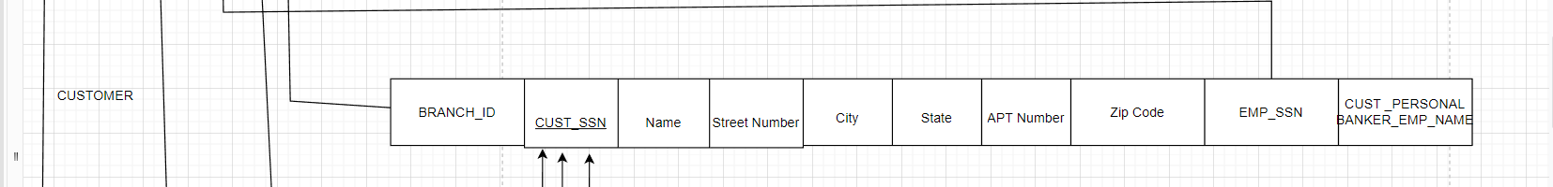

Primary key= cust_ssn

Foreign key= emp_ssn,branch_id

Super key= [Cust_ ssn , branch id], [Cust_ ssn ]

Candidate key= cust_ssn

**Functional dependencies**

Cust_ssn= name, street number, city, state, apt number, zip code.

Cust_ ssn , branch id -> emp_ssn, cust_personal banker name.

Cust_ssn, zip code -> name, emp_ssn,branch_id.

**Inserting values into customer account**

insert into sk3395_fall2022.customer values('A11922','MILLS',22,'portwills','newbrook','3-portwills',10079,'TIMS','A12389','SB001');

insert into sk3395_fall2022.customer values('A29383','JILL',32,'portwills','newbrook','4-portwills',10079,'hope','A14339','SB001');

insert into sk3395_fall2022.customer values('A09099','groot',82,'hillwills','newhill','2-hillwills',10009,'harry','A14119','SB002');

insert into sk3395_fall2022.customer values('A20003','hella',3,'hillwills','newhill','4-hillwills',10009,'bob','A21322','SB002');

insert into sk3395_fall2022.customer values('A09448','Jerry',36,'wayne','kitaa','4-wayne',10070,'john','A12422','SB003');

insert into sk3395_fall2022.customer values('A29000','tom',30,'wayne','kitaa','2-wayne',10070,'zane','A14991','SB003');

insert into sk3395_fall2022.customer values('A00123','gwen',100,'kinglanton','new tunu','4-kinglanton',10019,'emma','A14788','SB004');

insert into sk3395_fall2022.customer values('A00321','ben',110,'kinglanton','new tunu','2-kinglanton',10019,'marry','A23213','SB004');

insert into sk3395_fall2022.customer values('A09182','root',120,'victoria','wiluna','1-wiluna',10179,'mike','A14736','SB005');

insert into sk3395_fall2022.customer values('A02833','buttler',132,'victoria','wiluna','5-wiluna',10179,'will','A14999','SB005');

**This relation is in 3NF.**